Explanation of the Neural Network:
The neural network in the provided code is designed to learn the unigram probability distribution of tokens (in this case, characters) from a text corpus. It aims to estimate the probability of each token appearing in the text by maximizing the likelihood of the observed data.
- Inputs: The inputs to the learned function are one-hot encoded vectors representing the tokens in the vocabulary. Each vector indicates the presence of a specific token at a particular position in the text.
- Outputs: The output of the learned function is the log-probability of the data given the model's estimated token probabilities. Specifically, it outputs the total log-likelihood of the observed data under the current model parameters.

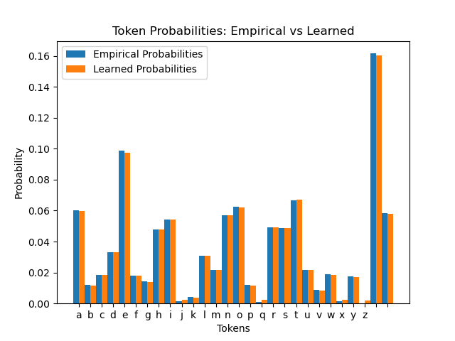
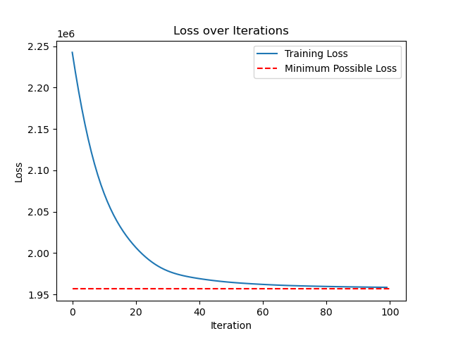
Modifying the Code for Document Classification:
To adapt this code for document classification, we need to:
- Change the Model Architecture:
  - Instead of learning unigram probabilities, the model should learn features that are predictive of document classes.
  - Replace the unigram model with a neural network suitable for classification, such as a simple feedforward network or an LSTM for sequence data.
- Prepare Labeled Data:
  - Obtain a dataset where each document is associated with a class label.
  - Tokenize each document and represent it using suitable features (e.g., word embeddings).
- Modify the Loss Function:
  - Use a classification loss function like cross-entropy loss.
  - The loss should measure the difference between the predicted class probabilities and the true class labels.
- Adjust the Training Loop:
  - For each document, compute the predicted class probabilities.
  - Calculate the loss using the new loss function.
  - Perform backpropagation and update the model parameters.

